1. Purpose:
IMEI tool is a tool for factory IMEI station. In this station, we should write IMEI, FSN, BT address, SIM data…etc. This tool is used to do these, and save the status in a log.

2. Scope:
In pilot-run, when you need to write anything in Factory IMEI station, you can refer to this document。

- Responsibility:
When development change the architecture, it need to be updated at the same time。

- Glossary of term :

- Flow Chart:
  - Set up IMEI tool
  - Download .csv file and cefs files.
  - Set the setup.ini file.
  - Plug unit and run the tool.

- Activities Description:
  - Set up IMEI tool
    - Get the IMEI tool from WGT2 daily build server:
\\qttwgt2public\QSyncherDailyBuild\\”Date”\\ MoblieToolKit
We suggest you to put this folder on C:\
    - Register SSSO2.dll
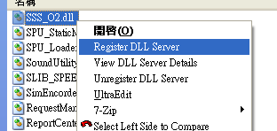
    - Register PICSInterface.dll
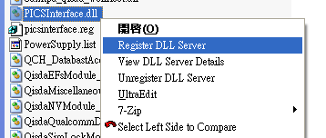
    - Send your user account to factory leader and ask them to register your account. Then you are able to connect to PICS server.

  - Download .csv file (for back up BRT) and cefs files.
    - According to the Model name and SW version of unit, create a folder in MoblieToolKit.
For example, if the Model name is GLAVS1A and SW version is V0.22, then create the folder \GLAVS1A\V0.22 in MoblieToolKit.
    - Get the .csv file from server, and put it on \MoblieToolKit\GLAVS1A\V0.22
    - Create a folder \Flex_Option in \MoblieToolKit\GLAVS1A, and put the .qvcefs files to this folder. You can get the .qvcefs files from our Official release server, for example, you can get the .qvcefs file of GLAVS1A V0.22 from:
\\wr1server\Official\01.Project_related\GLAVS1A_Lavernock\V0.22\Signed\Variant

  - Set the setup.ini file.
Open the setup.ini file and set the detail information, the meaning of each section is as below:
    - TOOL_VERSION
The version of this tool. Don’t change it.
    - TRANCIVER_INFO
The tranciver mode info. only write BT please ONOFF =1. write BT and IMEI, please ONOFF=0
    - CONFIG_VERSION
The version of Config Setting. Don’t change it.
    - DEBUG_INFOR
To generate the UI log file for debug. If you want to save the UI Log, set ONOFF to be 1.
    - MODEL_NAME
Set the Model name. You can add many model names here. Later you can choose your model name on tool UI.
    - SOFTWARE_VERSION
Set the Software version. You can add many versions here. Later you can choose your version on tool UI.
    - HARDWARE_VERSION
Set the hard ware version. You can add many versions here. Later you can choose your version on tool UI.
    - ME_VERSION
Set the ME version. You can add many versions here. Later you can choose your version on tool UI.
Usually this version is ‘A’.
    - PART_NUMBER
Set the part number of IMEI. Later you can choose your part number on tool UI.
This number is dependent on your IMEI. Please get the part number from factory Leader, or ITS administrator.
Moreover, create a section, which name is the part number you add, and set the transceiver number. Ex:
[9J.0NQPR.001]
TRANCEIVER_NO=SJUG5395AA
    - IMEI_MAL
      - IMEI_DIFFERENCE=1
The difference between last IMEI and the next IMEI
      - MAL_FIRST_PART=12345
The first part for MAL number
      - IMEI_FIRST_PART=35779502
The first 8 bits for IMEI number
      - LAST_WRITE_IMEI=356911020000158
Last written IMEI
    - CHECK
SW_CHECK
Whether do the check between SW version from UI and SW version from handset
HW_CHECK
Whether do the check between HW version from UI and HW version from handset
ME_CHECK
Whether do the check between ME version from UI and ME version from handset
PROCESS_CHESS
Whether do the check, all station before IMEI are pass
    - CONNECT_SERVER
a. ConnectServerCycleCount
If the tool connect to server fail, howmany times does it retry.
b. ConnectServerTimeout
When connecting to server, set the timing of time out (in mini-second).
c. WriteSIM_Delay
After writing SIM data, we should sleep for a while and then do the next cmd.
This parameter is to set this timing (in mini-second).
d. COMPORT
Set the DIAG port number of your phone.
    - MODEM_PORT
Set the MODEM port number of your phone.
    - SOFTWARE_PATH
Set the path of .csv file (for back up BRT).
    - SO_NUMBER
The last SO number, but this parameter is not used now. Don’t care about it.
    - TEST_RECORD
Record of running result.
    - SIM_FILE_NAME
Set the .loc. It’s used to generate the SIM data.
Note: For Melos model, the .loc file name is gotten from phone, so this parameter will not be used.
    - BRT1_BACKUP_SET
Before we write anything to the phone, we can backup BRT at first. If you want it to back up BRT, set BRT1_BACKUP to be 1, else, set it to be 0. You can set the parameter BRT1_BACKUP_PATH to set the Back up BRT path.
    - QCN_BACKUP_PATH
After we pass all the IMEI station flow, we will backup BRT again. You can set the parameter QCN_BACKUP_PATH to set the Back up BRT path.
    - PICSFILE_PATH
Tool will write some contents into a file (named: mobileID_HMS.ModelNameEID), in this file will record some station information: SO_number, ModelName, Hose….
This item defined the path for this file.
    - LENGTH_SETTING
You can set the length MSN, GSN, BT, IMEI, MAL, FSN, Mobile ID, and SIM data here.
  - Plug unit and run the tool.
Use EMU cable to connect the phone and run this tool. 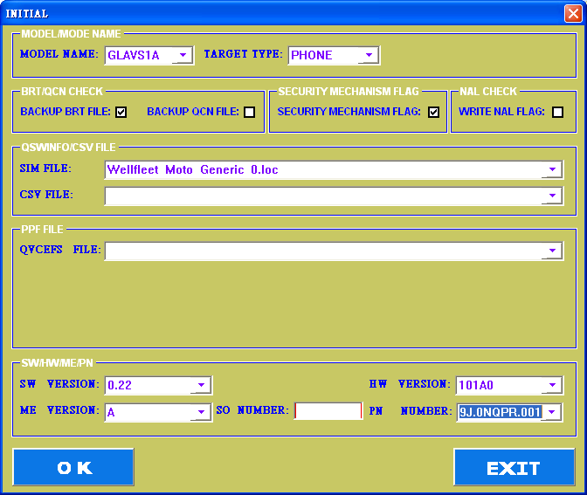
Select the Model name.
Check if you want to backup BRT (in the final step of IMEI station flow), if yes, select the CSV file.
Select the QVCEFS FILE.
Select the SW version, HW version, ME version, PN number.
Input SO Number and press OK. Then the following window pops up.
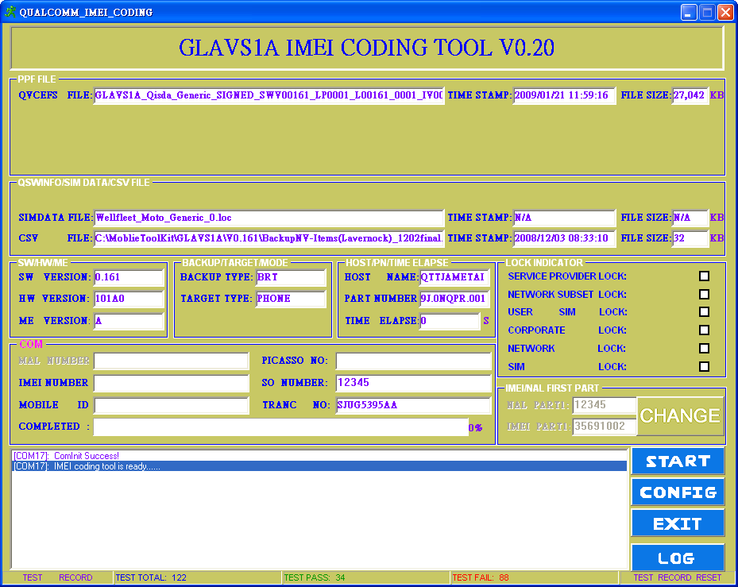
Input the PICASSO NO (that is the same as TrackID).
Input the IMEI number, this number will be written into the phone and freeze. If the phone has been freeze OTP, then input the IMEI number in the phone.
Press START!
If every thing is smooth going, it will show PASS.
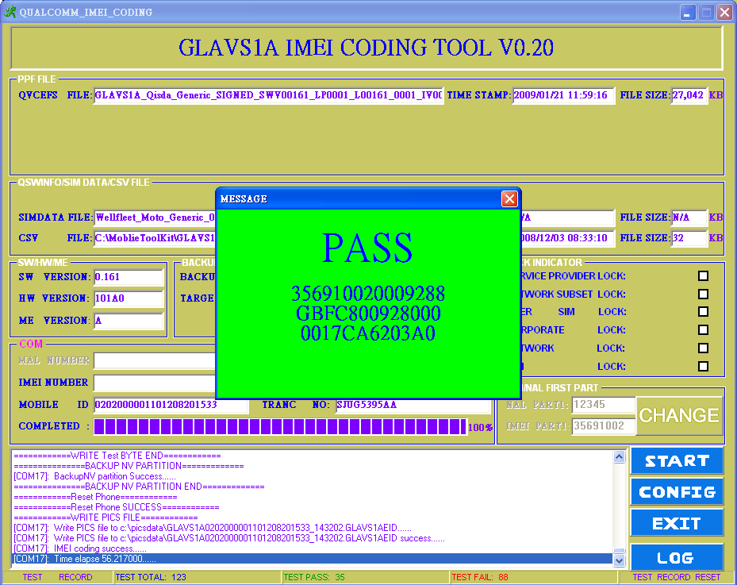

If it shows fail, check the error message:
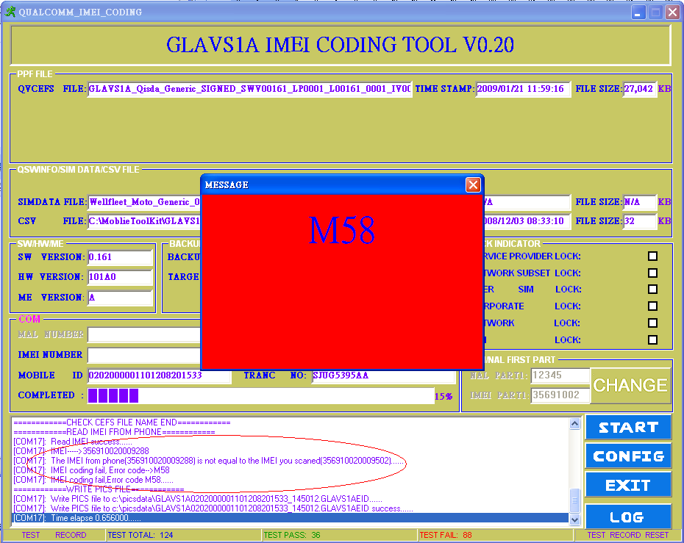
Fix the root cause and run again.

  - Log
After running, we saved some log in \MyDocument\Log.
    - SPU_RunTime.csv
Save all spending time of each step in IMEI station flow.
    - Status report (Named by TransceiverKitNumber, ex: SJUG5395AA.csv)
Save the status of each unit in this Transceiver Kit
    - USB command log (Named by the MobileID, ex: 01010000000903090_0237.txt)
Save the USB command of this port.

- Authority of Document Revised:
Notify tool team leader when it had be changed.

- Forms generated from this document:

- Reference :
